"The irony of the modern market is that it can get a spare part from across the world, but a neighbor still might not know that the mechanic with the skills to fix the car is right next door." – Donnie Maclurcan, Offers and Needs Market Creator

What’s the Offers and Needs Market?
Welcome to a place where talents are treasures and desires are delivered!
The Offers and Needs Market (OANM) is a lively, guided exchange where groups swap skills, stuff, and support – anything from tech help to a new mindset to the food on your plate. Whether it’s free, bartered, or paid, it’s all about better knowing that what you offer matters and what you need is valued.
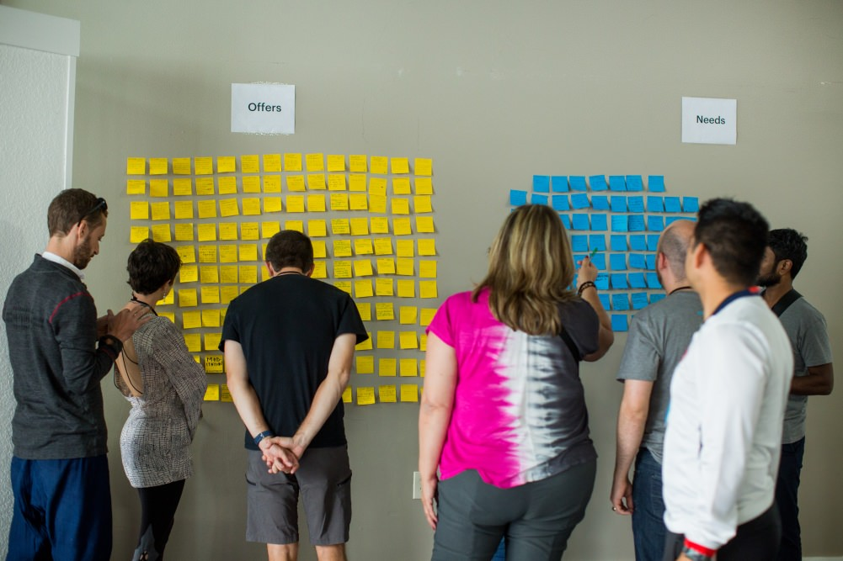

Why It's Powerful
Out of the many experiences I've facilitated since 2010 and participated in as an adult, the OANM is the only one that practically guarantees a delightful combination of possibility, relationship-building, surprise, and actionable paths forward.
With this process, I've seen people transform their health with a single exchange, plant the seeds of life-long friendships, get really good at asking for help, smile more than they have in ages, boost their confidence and comfort with vulnerability, and spring into making seriously rad things happen.
There's rarely been a time in history when trust-building activities like this are more necessary. It works across cultures and brain types, focuses on what we already have or can do, and honors your life-long experiences without needing any specific one to get a ton from it. The emphasis is on creating and sustaining a mindset of what you can do to help – and get helped – right now.

Table of Contents
What’s the Offers and Needs Market? 1
Why It's Powerful 1
Table of Contents 2
Major Notes about My "Digital Wall" Design Philosophy 3
Notes about My Style 4
Assumptions about Your OANM Choices 4
Formatting Cues in This Document 4
The High-Level Process 5
How an OANM Creates and Helps Communities 5
The Checklists 6
The Run Sheet 8
Facilitator Preparation and Prerequisites 9
Marketing Your OANM 18
Day of Market Facilitator Preparation 22
OANM Real-Time Process 26
Administrative Steps After Ending the Event 42
The Follow-Up 43
Miscellaneous Tips 48
What Now? 48
Changelog 48
Other OANM Facilitator Guides 48
Acknowledgments 48

Major Notes about My "Digital Wall" Design Philosophy
This guide is a way to run online OANMs that eliminates mandatory pre-work for participants, and often even the need for a companion Participant Guide. Folks just show up, generate their offers and needs live with guided prompts, browse a shared visual board, and find matches in breakout rooms.
It's intentionally designed to feel like an in-person gathering – including moments of waiting, silence, and not being able to talk to someone immediately. These "inefficiencies" are features, not bugs. They create the same serendipity and human-scale pacing that make in-person OANMs feel alive.

Some Brief Context
My original online OANM process – which is no longer updated – requires participants to submit their offers and needs 72+ hours before the live event. It's still useful when you have a huge pool of potential participants and reliably produces high-quality, edited offers and needs before the live market even starts. But the prep work requirement and overall process has significant downsides like:
- Not enough people do the prep work or you don't have enough offers/needs variety – which can lead to canceling the event.
- If you cancel, the prep work people did is often wasted.
- People are really bad at reading and/or following instructions in an event description. For example, I previously asked people to read a four page participant guide and almost nobody did.
- The process works best with a 3+ week lead time for promotion and prep. Many people don't have time or the ability to plan for that.
- Most offers and needs submissions only happen because I sent reminder emails to people who registered / RSVPed. There's a lot of manual work involved from the facilitator's perspective.

The "Digital Wall" Approach
It's my default online OANM process as of May 2026 and eliminates all of the issues with my previous prep work heavy approach. Better yet, it still preserves the spirit and quality that makes OANMs valuable.
The "Digital Wall" approach takes the best of my offline OANM process – silent writing time, physical sticky notes on a wall, browsing and matching in real-time – and adapts it for flexible online tools.

The Hybrid Prep Model
The Digital Wall still allows for thoughtful people to create their offers and needs in advance. Early submission is welcomed, but never required.
Early submissions appear on the digital wall immediately, giving you something to work with and potentially share even before the live event starts.
During the live event, everyone – including people who submitted some or all of their offers/needs in advance –– goes through the guided generation rounds. The category-by-category prompts reliably surface new offers and needs that people didn’t think of during solo prep so the planful folks are never sitting idle. They’re generating more entries or getting a head start on browsing the board.

Notes about My Style
My general facilitation style is comprehensive. So you might be better served using another facilitator toolkit.
The only other one I can recommend as of May 2026 is from the Post Growth Institute OANM Facilitator Training. But you'll have to do their training to get access to it.
If you want to do it my way, I recommend you have at least some of these qualities or the process may feel more frustrating than satisfying. Ideally, you:
- Enjoy attention to detail.
- Are willing to do some work up front to make the real-time market experience better for everyone.

Assumptions about Your OANM Choices
There are several assumptions baked into this style of OANM. You're free to make different design decisions, but it means big adjustments to what's proposed in this guide.
Here are my operating assumptions:
- You're running it by yourself with no co-facilitators and no event co-organizers.
- You have access to a video conferencing platform, permission to create breakout rooms, and understand how to use the breakout rooms.
- You're using a free digital wall tool like Padlet. Paid equivalents like Miro work as well, but I don't assume you have the funds for or knowledge of using paid digital walls.
- You have a $0.00 budget to run the event.
- There's no financial registration fee to participate.
- It won't be recorded and will be two hours or less.
- You already know how to use common online tools like Google Drive, spreadsheets, and/or Zoom.
- You aren't running this as part of an unconference. The unconference "Law of two feet/mobility" – meaning people who aren't learning or contributing can use their virtual two feet to leave – doesn't mesh well with this style of OANM.

Formatting Cues in This Document
You'll see some formatting in this document that prompts you to either read something verbatim or take an action. Here's a brief guide to what each formatting implies:
[Anything that's in brackets like this and colored red is a placeholder for you to customize with your specific context or a prompt to do an action]
"Anything that's indented like this and contains quotes (") is intended for you to read verbatim or customize to your tone, length, and style."

The High-Level Process
Here are the major steps along with a suggested minimum and maximum length of time for each one:
- Arrive, Orient, Housekeeping, and Demonstration (10-15 minutes): Welcome, context, and digital wall walkthrough / live demo.
- Create Offers (12-15 minutes): Four guided rounds (Heart, Head, Hands, Human Connections) with enforced silence and real-time updates to the digital wall.
- Create Needs (10-12 minutes): Four more guided rounds with the same structure as offers.
- Browsing the Digital Wall Demonstration and Silently Exploring (5ish minutes): Facilitator-guided tour of the digital wall, then silent browsing. Participants react to offers or needs that interest them with a typed comment or another provided method.
- Exchanging Offers and Needs (30-60 minutes): Breakout rooms for one-on-one conversations about potential matches.
- Spotlight, Survey, and/or Group Reflection (10-15 minutes): Optional spotlighting of standout offers/needs, real-time survey, and group reflection
- End the Event (5-7 minutes)
Total Time: 90-120 minutes. You can do it in 75 minutes or less, but I wouldn't advise it.

How an OANM Creates and Helps Communities
- Stronger Bonds: You get to see who knows what, who needs what, and who’s got your back.
- New Possibilities: People team up to make things happen in ways they couldn’t alone.
- It’s Fun (Seriously): Want an accountability buddy, creative sidekick, or ukulele jam partner? Those are real examples among endless options.
- Quick, Real Feedback: Share an idea or project, get thoughtful responses right away, and learn how it might be life-changing.
- Less Waste: One person’s extra is another’s perfect fit – saving time, energy, and resources.
- More Ownership: The more you give and receive, the more committed you feel. Now you, and the group, are about what’s abundant instead of what’s scarce.
- Confidence Boost: Asking for what you need and owning your gifts? That’s real power.
- Super-Efficient: It taps into what already exists … people’s often-hidden talents and treasures.
- Multiple Exchange Modes: Gift, barter, or commercial market? Yes to all three in one place!
- Feel-Good Science: Giving makes people happier and healthier with tons of research to back it up.
- Safe for All Personalities: Are you shy, introverted, neurodivergent, or just show up in a unique way? Connections and exchanges come easier here.

The Checklists
You may want to add reminders to your calendar for each of the checklists or some items in a specific checklist. Even seasoned facilitators can forget some of the key steps!

Facilitator Preparation and Prerequisites
☐ (14+ days ahead) Create your unique templates to send to participants.
☐ (14+ days ahead, optional) Recruit some helpers.
☐ (14+ days ahead, optional) Survey potential participants about their accessibility needs.
☐ (14+ days ahead) Create the event invite.
☐ (7+ days ahead) Adding examples or your real offers / needs to the digital wall
☐ (3+ days ahead, optional) Create your run sheet.
☐ (2-3 days ahead) Give co-facilitators or backups admin access to key files so the show can go on without you (if necessary).
☐ (48 hours ahead) Email all participants who submitted their offers and needs with the key information for the live market.
☐ (2-3 hours ahead) Email all participants again with the key information.

Marketing
☐ (14+ days ahead) Create reminders to promote in specific places at specific times. Space out the promotion so you're not doing all of it in a short period of time (e.g., a group email on one day, social media barrage the next day, and personal invites the following day).
☐ (4-14+ days ahead) Promote. One of your needs may be asking others to help you market the market. ;)
☐ (4+ days ahead) Make a "go/no go" decision about running the event based on the number of registrants or RSVPers. If you're canceling the event, communicate with all people who registered, RSVPed, already submitted their offers and/or needs, or otherwise expressed interest in participating.

Day of Market Facilitator Preparation
☐ (20-30 minutes before) Set up your physical environment.
☐ (20-30 minutes before) Open key digital files.
☐ (20-30 minutes before) Get any pre-populated polls ready to go.
☐ (20-30 minutes before, optional) Turn on the video conferencing waiting room.
☐ (15+ minutes before) Configure your breakout rooms.

The OANM Real-Time Process
☐ (3-5 minutes) Welcome and provide context.
☐ (3-5 minutes) Run through the housekeeping items.
☐ (As long as you need) Run the live exchange of Offers and Needs.
☐ (3-5 minutes) Spotlight specific Offers and/or Needs.
☐ (7-8 minutes) Have participants complete the real-time survey.
☐ (As long as you want) Give participants time to reflect on the experience.
☐ (5-7 minutes) End the event.

Administrative Steps After Ending the Event
☐ (3+ days ahead) Stop new submissions and remove links/access to submit offers and needs.

The Follow-Up
☐ (1-3 days after, optional) Export the contents of your digital wall.
☐ (1-3 days after, optional) Edit the digital wall export.
☐ (1-3 days after, optional) Aggregating participants' offers and needs.
☐ (1-5 days after) Send the recap email.
☐ (1-5 days after) Review the end of event survey results.
☐ (1-7 days after, optional) The other stuff.
☐ (7+ days after) Plan your next OANM. :)

The Run Sheet
A run sheet is a list of procedures or events organized in a specific timed sequence. They help break an overall process into chunks where you can pace yourself, see who's involved at any point (and for how long), when breaks will take place, contain notes or prompts that you might otherwise miss, and more.
My ideal online OANM event is two hours, although I've done it in as little as 90 minutes when necessary. You won't know how long you want your OANM to take you – or how long it might actually take you – unless you have your own run sheet or another document that sets your pace for each part of the facilitation.

Facilitator Preparation and Prerequisites

Digital Supplies and Knowledge
- An Internet-connected device with a 7-inch (18 cm) screen or larger. Your best and most efficient experience is on a laptop or desktop computer.
- Video conferencing platform (e.g., Zoom) installed and a general understanding of how it works.
- A "Digital Wall" tool (e.g., Padlet or Miro).

Why Padlet is My Default Digital Wall Tool
I've tested many digital wall tools and strongly prefer Padlet for a few reasons:
- The free version is way more than enough and has features that are normally available only with paid equivalents.
- It's available in almost all countries and the most popular languages.
- Participants can add offers and needs without creating an account.
- There's granular control of so many settings, and the default settings are great if you don't want to bother with nuanced configuration.
- It looks like a wall of sticky notes!

The Ideal Environment
- A quiet space that's light on physical distractions.
- Disabled notifications on your mobile devices so you can stay fully present.

Templates and Digital Tools

Make a Unique Version of Padlet Offers and Needs Digital Wall Template
This is where the magic happens. Your digital wall is the online equivalent of a physical wall full of sticky notes.
Note: You'll have to do a lot of configuration work if you choose to use a tool other than Padlet. That includes, but isn't limited to configuring and ordering the custom fields – which I've very intentionally designed – and testing the submission process for people who aren't logged into the tool.
- Create a Padlet account if you don't already have one.
- Click this Template: Offers and Needs Market to remake / copy my digital wall template.
- Click the settings icon.
Note: If a setting isn't listed below, don't change it. I've intentionally set your defaults based on a lot of trial and error. You'll break some of the core facilitation process if you do change things I don't mention.
Design Decision: The submission form field order is intentional. It flows from most essential to least essential: What is this? > How do I connect? > On what terms? > Where and when? The first six fields are required – meaning each submission takes a bit longer – but produces a complete entry that doesn’t need your editing. Availability (how often / how many) and Expiration Date (which handles time-bound need urgency) are optional because they don’t apply to every entry.
- Change the configuration of these settings.
  - Heading > Title (e.g., "[YYYY-MM-DD] [Event Name] Online Offers and Needs Market")
- Consider changing the configuration of these settings:
  - Heading > Description (I prefer mine blank to save space for people viewing on mobile devices)
  - Heading > Icon
  - Appearance > Wallpaper color
  - Appearance > Color scheme
  - Appearance > Font
  - Content > Copy protection (I recommend you disable remakes so people can't make a personal copy of your digital wall)
  - Advanced > URL
- Click the "Share" button for the digital wall
Note: Don't adjust these specific sharing settings. Doing so will prevent someone who isn't logged into Padlet from submitting offers and needs – and that's a potential deal-breaker for some people because they don't want to create a new account to yet another service.
- Permissions > Visitors with a link
- Privacy options > Require password
- Privacy options > Require visitors to log in

- Click the link labeled "Submission form"
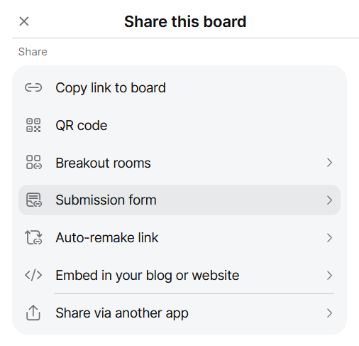
- In the Link section, copy the two individual links for Offers only and Needs only. You'll use these in OANM Event Description Template to give people an optional way to submit their offers and needs in advance.
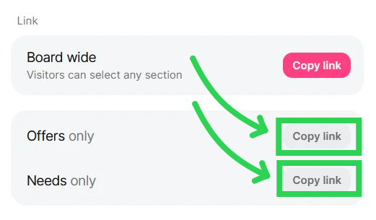
Design Decision: Don't give participants the "Board wide" link. That will generate a form that's confusing because it asks them to select whether their submission is an offer or need twice: once at the top and a drop-down at the bottom. It's the drop-down at the bottom that will cause issues because people submitting a need won't see it and their submission will technically be categorized as an offer – the default drop-down value.
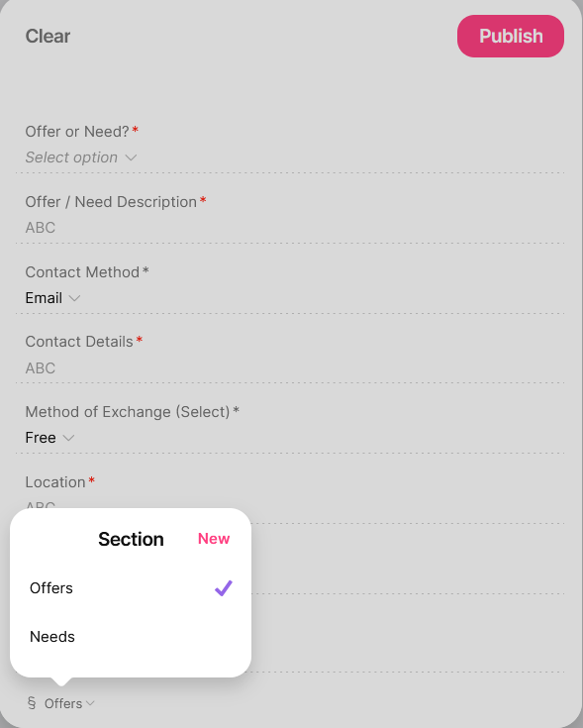
The "Offer or Need?" form field at the top is a safeguard. Even though the wall has separate Offers and Needs sections, people can still post to the wrong section by clicking the + Post button instead of using your submission form link. The badge on each card makes miscategorization visible so you can fix it.
- Click the "Share" button for the digital wall
- Click the link labeled "Auto-remake link"
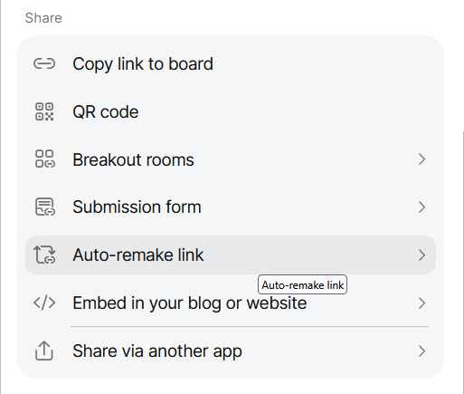
- Toggle off the Enable auto-remake link option so people can't clone / copy your digital wall.
Before
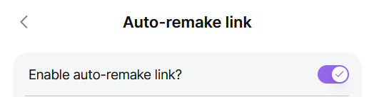
After
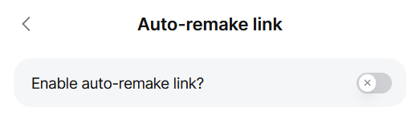

Make a Unique Version of Google Forms (Near the) End of Event Survey Template
- Click this Template: Online Offers and Needs Market (Near the) End of Event Survey link.
- Click the "Make a copy" button on the Google form prompt below where it says "Copy document … Would you like to make a copy of OANM Offers Survey?"
- Rename the file.
Example: [YYYY-MM-DD] [Event Name] OANM End of Event Survey
- Rename the "Online Offers and Needs Market (OANM) Survey" survey heading to something more appropriate.
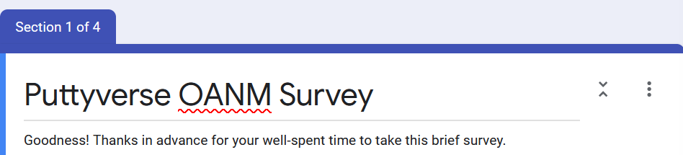
- Update the "[Your sign off (e.g., All the best], [Your full name]" placeholder at the end of the survey lead-in text.
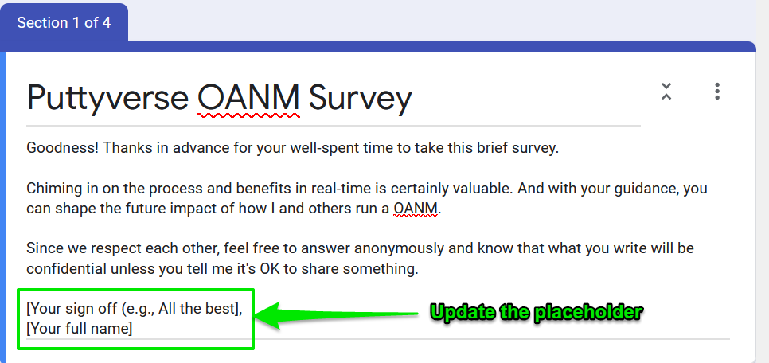
- (If necessary) Move the template copy from your root Google Drive folder into a OANM specific folder.
- Open the form.
- Click the "Send" button, then the "Send via … [hyperlink]" option, and then click the "Shorten URL" checkbox.
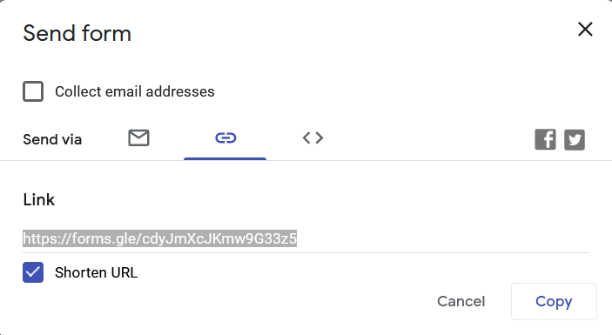
- Copy and paste the unique link into the Real-Time Survey section of this procedure document where you provide participants a link.

Recruiting Helpers
If you need help, ask for it! What better time than now to start making your needs known? ;)
After all, it’s more sustainable and fun to recruit others for key roles. Just make sure to define and schedule their tasks in advance so they don't have to guess what you need them to do, when, and who else is involved.
Pro tip: Explain why you think a helper would be great at a certain role. Be specific! Communicate the unique style, mindset, or skills that make you believe it will be rewarding for them and meaningful for everyone else. Also feel free to make tangible what they'll get from helping – a free ticket, a meal before/after, hugs, etc.
Consider the list of helpers below a good starting point:
Co-facilitator. The main face at a OANM doesn’t have to be you. But even if you’re comfortable doing things like facilitating group conversations and keeping the process on track, it can be great to have a co-facilitator to share responsibilities with and take over if you’re unavailable.
Promoter. Ideally, this person knows how to connect online and offline, understands effective promotional tactics that are aligned with the OANM spirit, and how to craft a compelling story. They also know how to implement the latest tech or old-school strategies. They can send emails, market on social media, engage people around town, and just generally be your OANM ambassador.
Moderator/Welcomer. Who do you know that radiates warmth and is quick with a smile? Who has a knack for fun chats, will help people feel comfortable right away, and will set a positive tone from the beginning? Put them front-and-center when you need it.
Moment Capturer (i.e., Photographer, Videographer, or Graphic Recorder). Everyone loves seeing and sharing pictures, videos, or creative illustrations of a meaningful get together.
Note: Use an opt-out approach: let participants know silence means they’re comfortable being photographed and ask anyone who isn’t to speak up. (e.g., “Raise your hand or tell me after the gathering if you’re not comfortable having pictures, videos, or other evidence of your presence here shared privately among us or publicly").

Identifying Accessibility Needs
This is something that the Post Growth Institute does particularly well with their OANMs. If you're going to solicit input or information from your potential participants, consider making a copy of this Google Form template to assess their accessibility needs.

Adding Examples or Your Real Offers / Needs to the Digital Wall
Participants will generally copy the examples you put in front of them.
So seed the digital wall with relevant examples or, better yet, actual offers and needs you want to exchange during the market.
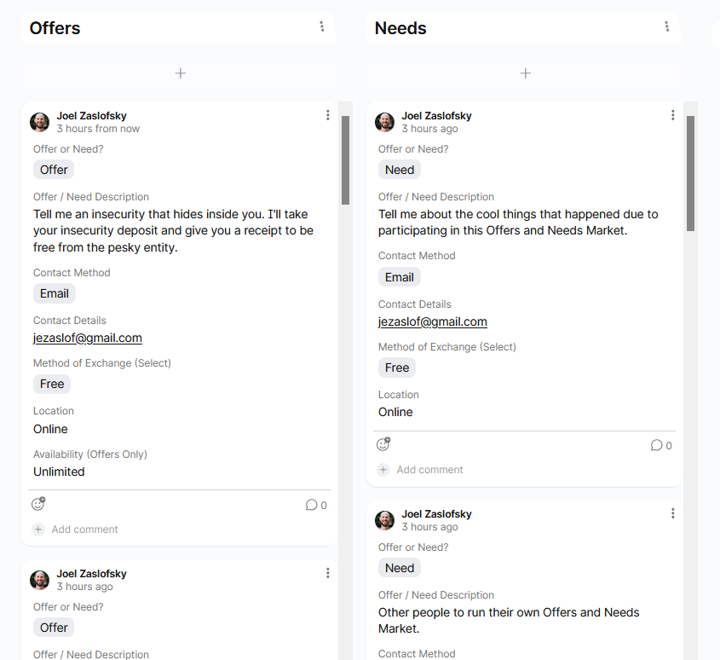

Email Reminders to Participants
I recommend an email reminder to RSVPers / event registrants 48 hours and 2-3 hours before the live event. But you can adjust the timing and number of email reminders to suit your needs.

48 Hour Reminder Email
Notes:
- Use the email address(es) people provided in their registration, RSVP, or already submitted offers and/or needs to test if any of them are invalid. You don't want a participant to contact another participant with a known bad email address if you can help it.
- Make sure all email addresses are on the bcc line.
Subject Line: What you need for our [brand associated with the event (e.g., "My Awesome Brand Name")] Offers and Needs Market in [X] hours
Email Content:
Hi wonderful [humans/name the community or group refers to themselves as (e.g., multipotentialites)] who are participating in our [brand associated with the event (e.g., "My Awesome Brand Name")] Offers and Needs Market!
I'm stoked to see you on [date you're running the OANM (e.g., May 19)] at [Start time in the three most common time zones for North America and Europe (e.g., "11:00 a.m. PDT / 2:00 p.m. EDT / 20:00 CEST")]. And since you can clearly follow directions as you already read the event description and [registered/RSVPed], here are some other things that will help you get the most from your upcoming experience.
- We'll be meeting [name of online platform you're using to host the event along with a specific link (e.g., "in this Zoom room")]. Use passcode [add one here if you have it configured for your Zoom room] in case you're asked for it.
- Some participants [have already/may] [sent/send] some offers and needs before the real-time market begins. That's encouraged … and totally optional! You can do some optional prep work by using this form for offers [hyperlink to the offers specific submission form on the "this form for offers" text] and this form for needs [hyperlink to the needs specific submission form on the "this form for needs" text].
- Click here to see the digital wall for the event [hyperlink to the Padlet board on the "Click here to see the digital wall for the event" text] and what's been added so far.
- Want to know the general flow of the event and what to expect? Check out page [X] of your participant guide [hyperlink to your participant guide on the "Check out page [X] of your participant guide" text].
- Want to remember what the Offers and Needs Market is all about? The event description will help [hyperlink to your main event ticket/RSVP page on the "The event description will help" text].
- Consider blocking off 30-60 minutes on your calendar shortly after the event ends to start or follow up with any conversations.
I'm excited we'll be together soon for a great exchange!
[Your preferred sign off]

2-3 Hour Reminder Email
Notes:
- Use the email address(es) people provided in their registration, RSVP, or already submitted offers and/or needs to test if any of them are invalid. You don't want a participant to contact another participant with a known bad email address if you can help it.
- Make sure all email addresses are on the bcc line.
Subject Line: Live in [X] hours: our [brand associated with the event (e.g., "My Awesome Brand Name")] Offers and Needs Market
Email Content:
Hi again wonderful [humans/name the community or group refers to themselves as (e.g., multipotentialites)] who are participating in our [brand associated with the event (e.g., "My Awesome Brand Name")] Offers and Needs Market!
I'm jazzed to see you in [X] hours for some great matches and surprising exploration. Please show up right when we're scheduled to start so you can get the full experience. :)
Here's some key information so you'll have everything at hand when we begin.
- We'll be meeting [name of online platform you're using to host the event along with a specific link (e.g., "in this Zoom room")]. Use passcode [add one here if you have it configured for your Zoom room] in case you're asked for it.
- Click here to see the digital wall we'll be using for the event [hyperlink to the Padlet board on the "Click here to see the digital wall we'll be using for the event" text] and consider signing up for a [Padlet / Miro / Your Digital Wall Tool of Choice] account for some extra benefits.
- Feel free to remind yourself of the general event flow and what to expect. It's on page [X] of your participant guide [hyperlink to your participant guide on the "It's on page [X] of your participant guide" text].
- Consider blocking off 30-60 minutes on your calendar shortly after the event ends to start or follow up with any conversations.
Don't share the [name of online platform you're using to host the event (e.g., Zoom room link)] or [Padlet / Miro / Your Digital Wall Tool of Choice] links with anyone else as they're only for active participants like you. :)
Get ready for a great exchange starting in [X] hours!
[Your preferred sign off]

Marketing Your OANM
Often, you'll need a concise description of what your OANM is, how it works, and how participants benefit.
See a template below that you can tweak for length, style, and your unique needs. Add some images and mix up the styling of the text (e.g., block quotes) to provide some visual interest.

OANM Event Description Template
Event Title
The Offers and Needs Market: [Your Subtitle Here If You Want One]
Event Summary (If Necessary)
- Where talents are treasures and desires are delivered
- Where kindness is currency and community is wealth
- From "I need" to "we have" – building together/together we thrive
- Small exchanges, big connections, stronger communities
- A lively exchange of skills, support, and serendipity
- A joyful way to give, receive, and thrive
Recommended Lead Event Image
This is the default image I use.
You'll have to give image credit to Armosa Studios if you use it.
Event Description
Welcome to a place where talents are treasures and desires are delivered!
The Offers and Needs Market (OANM) is a lively, guided exchange where groups swap skills, stuff, and support – anything from tech help to a new mindset to the food on your plate. Whether it’s free, bartered, or paid, it’s all about better knowing that what you offer matters and what you need is valued.
What to Expect
The OANM has helped participants find work, a place to live, meet new friends, and discover a deeper sense of belonging. Every exchange builds connections, those connections weave stronger communities, and more trust creates more possibilities.
Let's celebrate what we do have, showing how we can help – and get helped – right now.
The High-Level Process
- Think about what you might offer to or need from your fellow [whatever name your group or community identifies with]. The participant guide has all the context you want.
- Type those offers and needs on a provided digital wall.
- Browse people's offers and needs.
- Find someone you have a potential match with and chat in a breakout room.
- Repeat steps 3-4 as much as possible.
Are you looking for inspiration? Here's a spreadsheet with real examples of offers and needs from various gatherings.
Optional Preparation
A little advanced thinking and doing helps make the live event feel like magic instead of small talk. Yes, it's totally optional … and totally encouraged. :)
- Create a [Padlet / Miro / Your Digital Wall Tool of Choice] account [hyperlink to the digital wall tool account sign up process on the "Create a [tool name] account" text] if you don't already have one. This will be our shared space and registering with them allows you to [add key benefits here (e.g., "edit your submissions, speed up your data entry, and easily track the digital wall activity")].
- Use this form for offers [hyperlink to the offers specific submission form on the "Use this form for offers" text] and use this form for needs [hyperlink to the needs specific submission form on the "use this form for needs" text]. [If you're using Padlet and my Digital Wall template, add "Please ignore the hidden title field at the top of each form."]
- Add a reminder to your digital or physical calendar so you remember to show up.
[Oh, and consider bringing a friend or two and uncover surprising ways to connect.]
Notes about RSVPs
[Add information about how to RSVP, notes about the capacity for the event (e.g., the first 100 people), or anything else about RSVPs]
How to Join the Live Market
[Add information about how and where people will participate live. For example:
"We’ll be on Zoom, so you'll want a device with video and audio, plus a quiet space if possible."
Click this Zoom room link [add a hyperlink on the " Click this Zoom room link" text] when we’re scheduled to begin and join us for some surprising exchanges!]
Just One More Step …
I’d be grateful if you RSVPed "Yes" so I can plan for a certain number of participants. [Add information about how they can easily get the details on their digital calendar (e.g., "You may also want to use the 'Export' feature on the event detail page to make sure this event makes it on your calendar").]
Don't let a blind spot on your calendar or the wrong time zone conversion keep you from this unique experience!
Questions?
Contact [your full name] at [your best email address or other contact method].

OANM Social Proof
If you feel like it'll help, you can use any testimonials you find on my OANM landing page or link people to the offersandneeds.com The OANM Impact page.

Social Media Share Templates

Facebook / LinkedIn / Other Social Media
Welcome to a place where talents are treasures and desires are delivered.
Join us on [Date of event] for the online [brand associated with the event] Offers and Needs Market (OANM).
It's a lively, guided exchange where groups swap skills, stuff, and support – anything from tech help to a new mindset to the food on your plate. Whether it’s free, bartered, or paid, it’s all about better knowing that what you offer matters and what you need is valued.
[Add link to event detail page]
The OANM has helped participants find work, a place to live, meet new friends, and discover a deeper sense of belonging. Every exchange builds connections, those connections weave stronger communities, and more trust creates more possibilities.
Let's celebrate what we do have, showing how we can help – and get helped – right now.

X / Twitter
Join us for a highly interactive online event on [Date of event] [I/we] call it the Offers and Needs Market. Intriguing, right? :) It's where talents are treasures and desires are delivered, where kindness is currency and community is wealth. [Add link to event detail page]

Who to Invite
The OANM is for everyone, so consider these just the very tip of the iceberg. Your imagination and connections are the only limits here!

Groups
- Friends and family. Start with the people you already know and who already trust you. Mutual respect, shared experiences, and solid communication make for fertile ground to find participants.
- Organizations and communities you are or have been affiliated with. This could be online/offline work places, secondary and post-secondary education (e.g., high schools, community colleges, or school to work programs), maker spaces, or religious and spiritual groups (e.g., churches or yoga groups).
- Aligned meetup groups. Websites like Meetup.com or Facebook groups are good starts. Depending on your context, searching for these types of keywords or phrases can pay off quickly: barter, gift economy/exchange, community, time bank, or alternative economies.
- Anyone who self-identifies as generous, curious, or kind.
- Unemployment centers or other places where people may need to find work.

Personas
- The person who recently told you "I wish I knew someone who could…"
- The neighbor with many tools who loves lending them.
- The person between jobs who doesn't realize how much they have to offer.

When to Run an OANM
OANMs are versatile and work any time of the day, week, month, or year. If you're running one as part of a bigger event (e.g., conference), here are some tips on optimum timing:
- 1-day event: Run it right after the welcome/event introduction. OANMs make for great icebreakers, plus set a generous and candid tone.
- 2+ day event: Run it as early as possible on the second day. Participants should already be in an open mood and a bit more willing to offer or ask for help with people they know better.
Pro tip: Poll people to determine their ideal day and time instead of guessing. Find out with a poll from a free service like Xoyondo or Doodle.

Day of Market Facilitator Preparation

Set Up Your Physical Environment
You may not need these tips depending on your facilitator experience and tech savvy. But even Internet audio and video veterans could use some key reminders.
- Be available early. Being ready even five minutes before the scheduled time lets you work out any kinks or finalize any logistics.
- Be in a quiet room with little background noise. Think about fans, rustling clothing, dangling necklaces or bracelets, and open windows. Also, do your best to quiet pets or silence any electronic devices that might make sounds (e.g., cell phones, computer notifications, alarm clocks, etc.).
- Avoid jargon and explain terms or acronyms. Assume the participant doesn’t know what you know or may not understand what you’re talking about.
- Test your hardware, software, and settings. For example, configure your software to use the best microphone available if you have multiple. If you haven’t used specific hardware or software in a while, check to see if you have the latest drivers or version installed.
- Have water handy. You never know when your throat will get dry or a frog will jump in it.
- Rename yourself. Match the format you want your participants to use (e.g., Full Name / City, State, and Country or First Name)
- Get music ready if you're going to have it in the background or use it as a transition from one phase of the event to another.
- Remind the host to press the "Record" button (if you're recording the market).

Open Key Digital Files
You'll want to have these examples and templates open in your browser ahead of time so you don't have to fumble to find them when you're facilitating the OANM.
- The digital wall.
- The real-time survey.
- A digital copy of the participant instructions.

Note: If you have images you plan to screen share at some point – either locally on your device or on some online web page – load/access them now so they'll be at your fingertips later.

Get Any Pre-Populated Polls Ready to Go
Some facilitators like to poll their participants in real-time via a video conferencing platform. For example, you might ask how many offers and/or needs participants plan to follow up on.
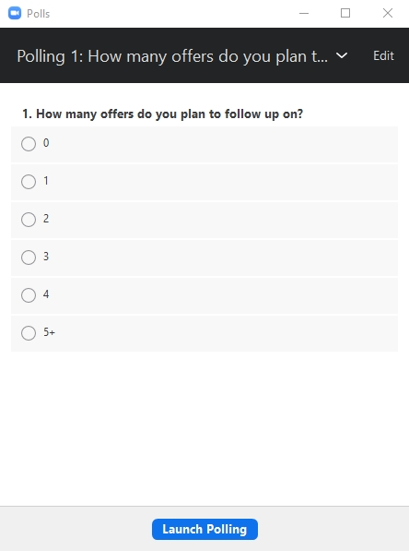
If the video conferencing tool you're using allows for polls, make sure that you've preloaded the poll information to the administrative back-end. That, or ask the people/host/moderator of the event to add the poll information for you.
For example, in Zoom, you would set up the polls at https://zoom.us/meeting/[MeetingID]. If you have the polls configured in your own Zoom account but you're using someone else's Zoom account for the OANM, they'll have to configure the polls in their Zoom account, too.

(Optional) Turn on the Waiting Room Option for Your Video Platform
You generally don't want participants entering your video room before you do or before you're ready to officially start the market. So turn on any kind of waiting room option to prevent people from joining before you want them to.
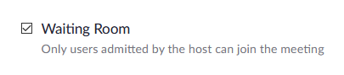

Configure Your Breakout Rooms
Save yourself the headache of setting up breakout rooms in real-time and do them in advance. Here's a rule of thumb to use when setting up the breakout rooms:
Number of people you expect at the OANM x 2/3.
Example: You expect 60 people come to the OANM and you make one-to-one breakout rooms for 2/3 of them. That means 40 total breakout rooms since many of them won't be in use at any given time. It may seem excessive, but Zoom keeps people (greyed out) in a breakout room even after they leave which makes it confusing for people to know whether the room is open or not. The more clearly empty breakout rooms are available, the better.
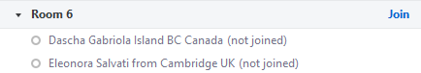

Zoom Breakout Room Configuration
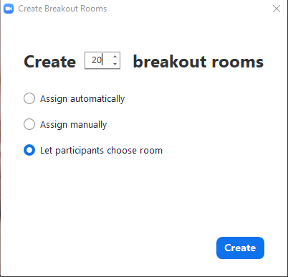
- Click the "Breakout Rooms" option
- Enter the number of rooms you want in the "Create [X] breakout rooms" number box.
- Select the "Let participants choose room" option.
- Click the "Create" button.
- Click the "Options" button.
- Use the following options
  - Allow participants to choose room = checked
  - Allow participants to return to the main session at any time = checked
  - Automatically move all assigned participants into breakout rooms when breakout rooms are opened = checked
  - Automatically move all assigned participants in breakout rooms to main session = checked
  - Breakout rooms close automatically after [X] minutes = [Whatever time you've allotted for the Exchanging Offers and Needs portion of the event].
Note about breakout room length: Many OANM facilitators have found a sweet spot with 10-12 minute breakout rooms. That allows participants enough time for some depth, but not so long that they unintentionally deprive themselves and others with more chances for connections. If you intend to have, for example, 10 minutes total in each breakout room session, set this value to 9. Combined with the "Set countdown timer" option, this ensures you have the exact minutes you want with the bonus of giving people a countdown timer for when they're forced back into the main room.
  - Countdown after closing breakout room > Set countdown timer = 60 seconds
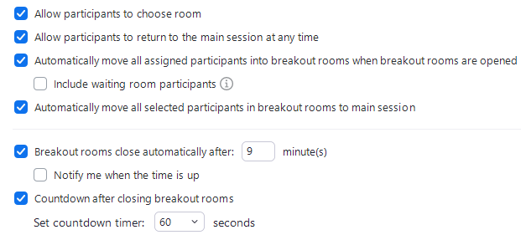

OANM Real-Time Process

Arrive and Orient (5-10 Minutes)
It's always good to get participants warmed up before the structure kicks in. Here are some tips to get people engaged with you and each other:
[If you're playing some music to energize people or set the mood for the event, start it now.]
[Say hello, with their name, to some people who have already joined. It gets their attention and makes them feel seen.]
"Welcome to a place where talents are treasures and desires are delivered."
"Over the next [amount of time together (e.g., "two hours"], we’re going on a collective treasure hunt – digging up the incredible gifts, talents, and resources hidden in this [group/community]. You might even be surprised by what you learn about people you already know."
"[I’ll/we’ll] be guiding you through a process that’s been happening, in one form or another, since the dawn of humanity and, more recently, around the globe as the Offers and Needs Market.”
"In a world full of impersonal exchanges, this is a refreshing change: a chance to connect, share, and discover on a human level. We already have so much of what we need waiting right beneath the surface; it just takes a little structure and serendipity to share it."
“Now, I invite you to close your eyes if that feels good. [Pause a few seconds.] Imagine you’re on bus with your fellow participants, heading somewhere exciting, yet still unknown. Can you feel the possibilities in the air? Do you sense the generosity and creative forces around you?”
“Slowly open your eyes and take in the names, faces, and energy of these people who came here to discover alongside you.”
[Ask people to rename themselves in Zoom with the name they provided when they wrote down their offers and needs and their current location (e.g., Joel Zaslofsky – Edina, Minnesota, USA). Changing their name in Zoom to match the name they gave when they wrote down offers and needs will make it much easier for people to reach out to them to start a conversation about one of their offers or needs.]
"If necessary, now’s the time to digitally rename yourself in Zoom to match the name you already provided when you submitted some offers and needs or will use when you add some to the digital wall. This will make it easier for your fellow participants to start a conversation with you when we get to the breakout room rounds. Feel free to check out how I've provided my name and something optional, like a location, as an example."
"If you're not already using a laptop or desktop, you might consider switching to one if that's an option. Using our digital wall or seeing things in the chat right away will be a lot easier with a decent sized screen."
[If necessary, explain the chat or video features of the platform so people know how to interact with you (the host/facilitator) or their fellow participants.]
[Introduce yourself or prompt co-facilitators to introduce themselves with whatever level of detail or context seems relevant. For example, "For those of you who don't know me, I'm … and I'm …"]
"Now let’s see if anyone has time constraints. If you know or think you have to leave before we're officially done, let us know your limitations in the chat so we can do our best to accommodate you."
[Invite participants to share their mood and energy right now in the chat.]
"I find it helps to make it known what your mood or energy level is coming into this experience. If you like, type how you're feeling in the chat and we'll pause for about 30 seconds to give everyone time to check in with themselves."
[Pause for 30 seconds and let people type in the chat. This is an engagement exercise and to prime people to pause for reflection and use the chat.]
[Talk about your goals for the OANM. For example:]
"If you're curious about why I take the time to run these OANMs, I want to help you all discover, elevate, and distribute all the untapped potential and generosity in the [community name] community. I also want to connect you with some awesome people you might not otherwise learn about or have a reason to chat with. There's more, but I'll leave it at that for now." :)
[Give the participants an overview of the segments of the market (with a visual screen shared image of the segments if possible).]
"So, how’s our time together today going to work? First, I'm going to cover some brief housekeeping items with some pro tips sprinkled in. Then we'll create our offers and needs with a simple framework and some prompts – or add to what you've already created if you put some on the board in advance. Next, we'll have a round of one-on-one conversations with people we see a potential match with. There will be other things to do if you'd rather not go into a breakout room. Finally, we'll match up some select offers and needs in real-time, debrief with a short survey, and have a group reflection about the experience. The whole thing should take about [X minutes for the rest of the overall process], starting now."
[Give people ten seconds to think about burning questions they have about the process and then type the letter "q" in the chat if they have one. Unmute people who have questions, let them ask, and answer as concisely as possible. This should only take 1-2 minutes before you move on.]
"If you have a burning question that simply must get addressed now for you to make the most of this OANM, type the letter 'q' into the chat. We have time for two to three quick questions and quick answers if necessary."
[Move on after ten seconds of silence.]
"Alrighty. Let's do some brief housekeeping."

Housekeeping Notes (3-4 Minutes)
Acting upon these housekeeping notes makes for a better and more valuable experience for everyone:
"Let's level up your experience with a few pro tips, the kind that might be the difference between 'decent' and 'Wow.'
First off, feel free to step away at any time. Grab a snack, go pee, you know – handle life. There’s no official break, so listen to your needs. Stay as long as you can for the full magic, but leaving early is totally fine.
This online space is designed to feel like an in-person gathering, which means patience is key. If someone’s deep in conversation in a breakout room, think of it like two people chatting in the corner at an offline event. You wouldn’t just jump in, right? Trust the flow, even if it feels a little slow.
I’ll also pause sometimes. Like, really pause. It’s intentional! It gives space for quieter folks, non-native English speakers, people who need more time to process, and everyone to reflect before we move on.
Mute and unmute as needed, but heads-up: I might mute you if something in your environment is distracting others. It's your call to have video on or off, but we love seeing faces! Matching and chatting are just more fun that way.
If you haven't already, consider creating a [Padlet / Miro / Your Digital Wall Tool of Choice] account before submitting your offers and needs. That allows you to edit your submissions, associate your name automatically with contributions, and easily track the digital wall activity. You can post without logging in, but a registered account speeds up your data entry and improves the collaborative experience.
[Put a link in the chat to the registration process for your digital tool]
[Create a Padlet account here: https://padlet.com/ ]
Now, does anyone have specific accessibility needs we should know about? For example, someone to read you text that you can't see or process in the chat?
[If people speak up and say they have a specific accessibility need, see if you can find a participant in real-time to be their designated helper]
"The OANM is both a community-building and trust-building activity. We assume that everyone has good intentions and nobody’s offering or vulnerability in sharing their needs will be taken advantage of. In other words, what we offer each other shouldn’t and won’t be exploited.
"OK. Now for the link to our digital wall where you'll see all the offers and needs."
[Give people a link to the main digital wall. Copy and paste the text below into the chat]
[Name of tool digital wall: hyperlink]
"Before we get into exchanging offers and needs, let's get our bodies and brains loose first. Let's take one minute to do some breath work, shake out your body, or otherwise do whatever will help you stay as present as possible with us for as long as possible. I'm going to wiggle and waggle my body a bit while I do some deep breathing, but you can do whatever you like."
[Let participants do breathework, shake it out, or whatever they need to do for one minute]
"Ahhhhhh. That was nice. :) You have permission to reset at any point by doing more breath work, moving your body, or whatever else feels good. We won't think it's weird. :)"

Digital Wall Demo (2-3 Minutes)
“Before we dive in, let me show you the tool we’re using today. It’s called [Padlet / Miro / Your Digital Wall Tool of Choice] and it’s basically a digital wall where we’ll put our offers and needs – like sticky notes on a wall, but online.”
“Watch me fill out a quick offer and need.”
[Screenshare and use the UI of the main wall to add your quickest offer or quickest need so people can see an example. If you don't want people accidentally using the hidden Padlet Subject field, put your cursor in that field and tell people to ignore it.]
“That’s the process. You fill out the form and your offer or need appears on the wall for everyone to see.”
[Give people ten seconds to ask a burning question about something they just saw and then type the letter "q" in the chat if they have one. Unmute people who have questions, let them ask, and answer as concisely as possible. This should only take 1-2 minutes before you move on.]
"If you have a burning question about what you just saw, type the letter 'q' into the chat."
[Move on after ten seconds of silence.]

Welcome People Who Joined after the OANM Officially Started (1 Minute)
[Name the people who you didn't verbally say hello to at the start of the OANM that joined later so they feel welcome and so that they know you know they're there (which helps them stay focused on the OANM). An example:]
"Hi [first name] and [first name]! You joined us a little bit later than some others, which is cool, and there's time to catch up. For anyone else who recently joined this Offers and Needs Market, welcome! Feel free to type the word "New" into the chat – and maybe we'll even say hi. :) We just discussed the spirit that guides our OANM, ran through some housekeeping notes, and are about to create our offers and needs. Exciting, right?!"

Creating Offers (12-15 Minutes)
"We begin with offers because they're almost always easier to think of and symbolic that we've come together to be generous. Offers are typically things that come from your head, heart, hands, or human connections."
"It's possible that the head, heart, hands, and human connection simplified framework doesn't work for you and, if so, use your own intuitive method of creating offers."
I'll soon share a few real examples in the chat if you need a spark, but don't feel like you need to read them. We'll take about [X] minutes to create offers around each of the four core gifts and the process will take about [X] minutes total. If you've already added some offers to the digital wall, you can start browsing it and looking for potential matches or follow the prompts and come up with more.
Remember: this is your chance to own your gifts and step forward confidently in what you can do or help others become.
We'll do this in silence. If you need something from me, send a direct message in the chat. OK – here's the link to add your offers:"
[Give people a link to the offers submission form. Copy and paste the text below into the chat.]
[Add an offer: hyperlink]

Head
"If you'd like a prompt, consider this:
What do you know enough about that someone else could learn from you? You don't have to be an expert here.
[Copy and paste the prompt in the chat.]
"I've set a timer for [X] minutes, so let's see what comes up for you and us. Remember that you can add multiple offers, but any number is fine, including none if you're coming up blank."
"I'm muting everyone so we can ensure silent reflection time."
[Copy and paste real world examples in the chat]
Head examples:
* I know a lot about habit formation and can help you break negative ones or stick with positive ones.
* I'll share my ridiculous, over-the-top comprehensive podcasting workflow document with you.
* I'll can help with my futures thinking / strategic foresight workshops for non-profits.
[Set your timer – either in the video conferencing platform so participants can see it, on your personal devices, or both.]
[Mute anyone who isn't already on mute]
[When the timer goes off]
"Feel free to continue your offer if you're in the middle of it. The rest of us will move on to creating heart-related offers."

Heart
"Here's the prompt:"
What do you care deeply about that you could share with someone or emotionally support them in? What cause or value drives you so much that helping someone with it would feel like a gift?
[Copy and paste the prompt in the chat.]
"I've set a timer for [X] minutes again. Let's see what happens."
[Copy and paste real world examples in the chat]
Heart examples:
* Let's talk about what's possible when you live from your heart instead of your head.
* I'll listen to you bitch about life.
* Peer support group for folks with mood disorders.
[Set your timer – either in the video conferencing platform so participants can see it, on your personal devices, or both.]
[Mute anyone who isn't already on mute]
[When the timer goes off]
"Once again, finish up your offer if you've started one. Most of us will transition to hands-related offers."

Hands
"Here's the prompt:"
What can you physically or digitally design, build, maintain, or fix that others might find useful?
[Copy and paste the prompt in the chat.]
"I've set a timer for [X] minutes. Use your creativity because sometimes it's the unconventional offers that resonate the most."
[Copy and paste real world examples in the chat]
Hands examples:
* I can create original music for your passion project.
* I can help you develop your story for a website, performance, or video.
* I will fold some inspired origami based on your request and send you a picture.
[Set your timer – either in the video conferencing platform so participants can see it, on your personal devices, or both.]
[Mute anyone who isn't already on mute]
[When the timer goes off]
"Keep going if you're in the middle of an offer. Everyone else: come along to the last offer category – human connection."

Human Connection
"Here's the prompt:"
Who do you know, what groups are you a part of, or what access do you have that could open a door for someone else?
[Copy and paste the prompt in the chat.]
"The timer is set for [X] minutes. It's OK if you come up empty or feel done with offers. The digital wall is available to silently browse if you want something else to do now."
[Copy and paste real world examples in the chat]
Human connection examples:
* I can introduce you to headshot photographers in my private club who live near you.
* Connections in the New York City tech community.
* I'll help you meet cool artists on social media who enjoy interacting with others.
[Set your timer – either in the video conferencing platform so participants can see it, on your personal devices, or both.]
[Mute anyone who isn't already on mute]
[When the timer goes off]
"Finish up soon if you're in the middle of your offer because we're about to begin creating some needs."
[If you have the time and desire, you can pause here and briefly ask participants if anything surprising came up for them while generating offers.]

Creating Needs (10-12 Minutes)
"Creating needs has the same structure as generating offers – it's just the other side of the exchange coin. Thinking of our needs or being vulnerable enough to share them can be hard. That’s exactly why it matters. We've come in the spirit of support and, since I don't believe any of us can read minds, your best bet to get something is to just go for it and ask.
For instance, what are you working on, seeking, or where could you use support? Feel free to think in terms of head, heart, hands, and connections again – just don't limit yourself if the framework doesn’t feel right."
"We'll do four rounds of generating needs, one for head, heart, hands, and human connection. I'll share some real examples in the chat to help you see what's possible, but you don't have to read them. We'll take [X] minutes for each round and the process will take about [X] minutes total. If you've already added some needs, you can browse the wall while the rest of us think and type in silence or follow the prompts and come up with more.
If you need something from me, send a direct message in the chat. Here's the link to add your needs:"
[Give people a link to the needs submission form. Copy and paste the text below into the chat.]
[Add a need: hyperlink]

Head
"Here's your first prompt:"
What skills or knowledge would make your life or work meaningfully better? Think about projects that are stalled, problems you’ve been working around, or talents you wish you had.
[Copy and paste the prompt in the chat.]
"I've set a timer for [X] minutes. Remember that you can add multiple needs, but any number is fine, including none if you're coming up blank."
"I'm muting everyone again so we can silently reflect together."
[Copy and paste real world examples in the chat]
Head examples:
* A simple process to automatically create backups for my computer or website.
* I really want to learn to play the ukulele and could use some very beginner lessons.
* I'd like to talk about healthy eating with my specific set of constraints (like family and food availability).
[Set your timer – either in the video conferencing platform so participants can see it, on your personal devices, or both.]
[Mute anyone who isn't already on mute]
[When the timer goes off]
"Feel free to continue if you're in the middle of something. Everyone else? Let's go to heart-related needs."

Heart
"Here are prompts:"
Where or when could you use some emotional support? What change do you care deeply about that you can't make alone?
[Copy and paste the prompt in the chat.]
"I've set a timer for [X] minutes again. Let's explore some possibilities as you name what you need."
[Copy and paste real world examples in the chat]
Heart examples:
* I just need more friends. Plain and simple.
* Can we be life accountability buddies? It's OK if you have chronic issues that might make interactions inconsistent.
* I need to practice dealing with conflict head-on, how to set boundaries without being rude, and being vulnerable.
[Set your timer – either in the video conferencing platform so participants can see it, on your personal devices, or both.]
[Mute anyone who isn't already on mute]
[When the timer goes off]
"Once again, finish up your need if you've started one. Most of us will transition to hands-related things."

Hands
"I hope you're getting the hang of asking for what you need. Consider thinking bigger, even more bold on this next category. Here's the prompt:"
What kind of physical or digital things do you want to design, build, or fix that would move the needle for you?
[Copy and paste the prompt in the chat.]
"I've set a timer for [X] minutes. Keep in mind that there's nothing too big or small to ask for here."
[Copy and paste real world examples in the chat]
Hands examples:
* Lessons and/or coaching in basic organic vegetable gardening.
* Interior design and home organization help for a family of six moving into a new home on a tight budget.
* I need a job or motivation to make some money. Take my various gifts/experience and merge them into something valuable.
[Set your timer – either in the video conferencing platform so participants can see it, on your personal devices, or both.]
[Mute anyone who isn't already on mute]
[When the timer goes off]
"Keep going if you're in the middle of a need. Everyone else: wander along to the last category – human connection."

Human Connection
"Here's are the prompts:"
Who do you wish you knew? What kind of support, accountability, or collaboration would change what’s possible for you?
[Copy and paste the prompt in the chat.]
"The timer is set for [X] minutes. It's OK if you come up empty or feel done with your needs and want to move on to exploring the board."
[Copy and paste real world examples in the chat]
Human connection examples:
* I'd love connections in the remote work world, specifically introductions that lead to informational interviews.
* I want to chat with storytellers from various walks of life who could guide me to expand my coaching work.
* People with experience self-publishing a book. Bonus points if they're spiritual in some way.
[Set your timer – either in the video conferencing platform so participants can see it, on your personal devices, or both.]
[Mute anyone who isn't already on mute]
[When the timer goes off]
"Finish up in the next 30 seconds if you're in the middle of your need. We're about to start exchanging all these fantastic items on the digital wall!"
[If you have the time and desire, you can pause here and briefly ask participants if anything surprising came up for them while generating offers.]

Browsing the Digital Wall Demonstration and Silently Exploring (5ish Minutes)
This is important because:
- Up until this moment, most participants have spent the entire time understanding the spirit of the OANM and creating their offers and needs. They've spent zero time actually looking at others offers and needs.
- Many people tend to just jump at the first offer or need they find intriguing and don't strategically decide who to approach. Giving silent browsing time increases the chance that they'll connect over something that really matters to them.
- Most participants aren't familiar with the built-in tools to make their browsing easier.
"I'm looking at our digital wall now and am both impressed and intrigued about what I see there. Nice going, everyone!"
"Stick with me for a few more minutes as I give you a quick tour of the wall and show you some tips that will help you make the most of it."
[Do a demo of how to:
- Comment on an offer or need.
- @mention someone to draw their attention.
- Note that a comment or @ mention might trigger an app or email notification for the person who posted the offer or need depending on their personal notification settings. Commenting or @ mentioning someone isn't a guarantee that they will see it during the event – it just increases the chances.
- Use the search filters to find just a single participants' contributions to the digital wall – including just their own items since they're mixed in with everyone else's.
- Use the search filters to find items with a specific status (e.g., where the method of exchange is free).
- Do anything else that seems relevant to you as a facilitator.
"Now it's your turn to browse. Take [X] minutes to silently explore the wall and, if you're using a small screen, the search bar may be your best friend."
[Set your timer for however many minutes you're giving people to silently browse.]
[Mute anyone who isn't already on mute]
[When the timer goes off]
"Our intentional process and your patience are about to be rewarded. Let's talk about all these great offers and needs!"

Exchanging Offers and Needs (30-60 Minutes)
Note: I strongly recommend you allow at least 45 minutes for the real-time exchanging of offers and needs. 60 minutes or more might be even better if you and your participants have the time. Having 3-5 rounds of conversation is essential for participants.

Overview
"I'm about to open up a number of breakout rooms for you to jump in and out of to discuss a potential match with another participant. We'll do at least [X] rounds of this.
"Here are your options right now:
  - Find someone you want to speak with.
  - Direct message them in Zoom and invite them to join you in a specific numbered breakout room. Remember: You can't message someone if they're already in a breakout room. Be patient. Also remember that people may be sending you private chat messages when you're not looking at the Zoom chat.
  - Keep messaging and hopping into breakout rooms each round until the real-time exchange portion of the market ends. [Tell people how long that will be]. You can take a break for any reason during any of the rounds or plan to follow-up with a participant if you don't want to speak for a bit.
  - I'll stay in the main Zoom room to answer questions, help assign people to breakout rooms if they can't do it themselves, and make sure things are flowing smoothly.
[Type the summary of the process into the chat with the text below]
Here's how the rounds of connection will work:
* Find someone you want to speak with.
* Private message them in the chat.
* If they respond and are available, pick a breakout room that's empty, tell the person you've agreed to speak with the number, and assign yourself to it.
* Plan how and when you're going to follow up with people.
* Use this main Zoom room to ask me questions or ask each other questions.
"If you have a burning question about the process, type a "q" in the chat and I'll field up to three of them quickly."
[Take 10 seconds of silence for participants to ask questions before moving on].
"OK. I'm starting my timer for [X minutes that the real-time exchange process will last]. The breakout rooms are about to be open, so connect, discuss, exchange, and explore in round 1, everyone!
[Click the "Breakout Rooms > Options" button to verify that your initial breakout room settings are still applied. Be sure to verify the "Breakout rooms close automatically after X minutes" option to make sure it's the right number of minutes].
[Click the "Breakout Rooms > Open All Rooms" button to open the breakout rooms].
[Start your personal timer for the amount of time people are in breakout rooms.]

Facilitator Actions While People Are in Breakout Rooms
Start a second timer to give people a five-minute warning through the video platform when you're going to bring everyone back into the main room from their breakout room. For example:
"We'll be gathering back in the main room in about five minutes."

Facilitator Actions after Each Breakout Room Round
- If you're using Zoom: in the Zoom breakout room panel, click the "Recreate" button. If you don't, people will be asked by Zoom to go back into the room they were just in when you click the "Open All Rooms" button again. Avoid this as it’s confusing and wastes time.
- When you're ready to open another round of breakout rooms, just follow the steps in configure your breakout rooms.
- Prompt people to look at their direct messages. Something like "If you haven't checked the chat or your direct messages recently, take a quick look. Someone may be waiting to speak with you."
- (Optional) After the 3rd or 4th round of breakout rooms, consider doing a real-time exercise to see how many more people each participant wants to speak with. There are many ways to do it, but my favorite is a “show of fingers.” Ask each participant to hold up the number of fingers on their hand(s) representing how many more people they’d like to speak with about a potential match. People who can’t use or don’t want to use video can just type a number in the chat. This will let you know if you should end the round of breakout rooms earlier than you planned so the gathering doesn’t needlessly drag on.

Facilitator Actions Once All Breakout Room Rounds Are Done
[If you're playing some music to re-energize people or set the mood for the next phase of the event, start it now.]
"I want to acknowledge that some of you didn't get a chance to talk to as many people as you hoped to connect with about a specific offer and need. That's a bummer, and the good news is you can still contact people after our time together here is done. Please, please – don't let a good offer or need go unaddressed."
"Before we get into shining a spotlight on some of you, an insightful survey, and some group reflection, let's get our bodies and brains loose again. Take another minute to do some breath work, shake out your body … whatever you feel called to do right now."
[Let participants do breathwork, shake it out, or whatever they need to do for one minute]
"Let's now take a silent minute to plan how and when we're going to contact someone or follow up about a match. I'm hitting the pause button now for you to put your mini action plan together."
[Be silent for one minute]
[(Time allowing) Ask people to put a "y" in the chat if they'd like to verbally share a particularly interesting or resonant offer they matched with (3 people max).]

Spotlighting, Survey, and/or Group Reflection (10-15 Minutes)

(Optional) Spotlighting
Allow each participant to verbally pitch one of their Offers or Needs. If they can't verbally pitch because the tech platform doesn't allow it or they're not able to speak, prompt them to enter it into the chat. Tell people to add their contact information in the chat after they've spotlighted their offer or need.
"Now’s your chance to spotlight one standout offer or need – something that deserves extra attention."
"There's no need for extra details. Just give us the offer or need itself, then your contact information in the chat. Keep it snappy!"
[Model the concise pitch with one of your example offers or needs.]
"I'll model how this is supposed to work. I'm Joel Zaslofsky and I offer to help you create minimalist spreadsheets without fancy formulas. Now I enter my contact information in the chat [enter information in the chat] and I'm done."
[Don't allow discussion or clarification during this step unless you have lots of time. It'll slow things down or allow extroverts to dominate the conversation.]
"That was it. If you want a discussion about or clarification of someone's offer or need, do it privately so we can keep things moving along."
"If you want to spotlight one of your offers or needs, type the letter "y" in the chat. We'll spotlight as many as we have time for."
[Have people unmute themselves and do a round of spotlights, pointing out when someone is going too long or not following your instructions.]
[While they're doing spotlights, consider taking a screen shot of all participants or just the ones who have their video turned on.]

Real-Time Survey
When you carve out intentional time during the live event to survey participants, the response rate and usefulness is generally much higher than if you ask people to fill it out after the market is over. Whatever survey you ask people to complete should take seven minutes or less (on average), preferably five minutes or less.
Some people incentivize survey completion by giving a reward to one or more people who complete it (e.g., a free consultation, access to your normally private resources, etc.). Decide ahead of time if you'll have a reward, how many, and what type.
[Explain to participants why your survey is so important that you've carved out time during the event to fill it out in real time.]
"Now for everyone’s favorite part of the OANM: the real-time survey. :) I promise it’s quick, insightful, and useful for both you and me. Some of my best changes to the OANM have come from past participants like you – generous and candid. So, if you’ve enjoyed this, or have ideas to make it even better, drop your thoughts in the survey link I’m sharing in the chat."
[If you have some kind of reward, mention the details now.]
[Share the unique survey link in the chat.]
End of OANM Survey: [add link]
"You have [7] minutes, but it'll probably take less. No worries if you don’t finish now. Just wrap it up later when you can. The timer starts … now!"
[Set timer for X minutes]
[Give people a verbal one-minute warning when the official survey time is almost up]
[Let people know the official survey time is over, but they can complete it later if they didn't finish]

Reflection Time
[Give people 30 seconds each to reflect on what you've just experienced.]
"OK. Let's reflect before we wrap up our time together. I've found that sharing your experience or hearing others' can boost confidence and spark new insights. I’ll put some reflection prompts in the chat if you need inspiration."
"Let’s hear what stood out for you!"
[Copy and paste the text below in the chat]
* What's something that surprised you about the experience?
* What did you learn about yourself or others through participating today?
* Did your self-identity change in any way during the OANM, even a little?
* How did the process challenge you?
* Did you find it easier to reflect on and share offers or needs?
* What are you excited to follow up on because of our OANM?
"Let's silently pause for one minute to gather our thoughts and then we'll share together."
[Set a timer for one minute and be silent]
"It's been one minute. If you have something you'd like to reflect on with the group – preferably in about 30 seconds or less – put a "y" in the chat. We might not get to everyone, but as always, I'll do my best to move things along without rushing us."
[As people type a "y" in the chat, call on them to verbally share for as long as you have time for]

End the Event
In general, you're just recapping what you promised to do as follow-ups and expressing gratitude for any co-facilitators, tech helpers, and participants who made this OANM special. Here are some things you could mention:
- Recap the spirit of the OANM (based on generosity and connection).
- Give an example of something that just happened in this OANM that reiterates why you enjoy them.
- Explain how and when you'll follow up with participants, and in what medium.
- If applicable, remind participants that they can share any matched or unmatched offers and needs with the wider community in whatever way they see fit.
- Thank any co-facilitator(s) or other people who helped you prep for, host, sponsor, or run the OANM.
- Thank your participants for showing up for themselves and their community.
- Prompt people that they can run their own OANM and how to get started (e.g., contact you or go to a specific website link to learn how).
- Give people permission to leave.
- Go into the bonus round: an anything goes conversation or nerding out about the event experience or themes of the event.
- End the meeting for everyone by closing out the video platform.

A Sample Script (6-7 Minutes)
If you don't want to ad-lib some of the items above, here's a sample script to close out the event.
"Before we part ways, let's ponder one question for a moment: What are you taking with you from this experience?
I'm not talking about a match or a story. What feeling or realization are you leaving with?"
[Pause 10 seconds.]
"If anyone wants to share in 1-2 sentences, go right ahead."
[Let 2-4 people share and acknowledge them after each person shares.]
"The matches are great and what often gets the headlines. But the moment someone realizes they have more to offer than they thought, or that asking for help is an act of strength rather than weakness? That's a huge benefit.
I'm so grateful that you all showed up. Not just on [video conferencing platform], but with your actual gifts and your actual needs. You had unpredictable conversations and came out with connections. That takes real trust.
I saw [specific moment from today (e.g., three people in the chat simultaneously realize they all need accountability partners)]. That's the OANM in action.
Here's what's next: I'll send a recap email within [timeline]. My main request is this: follow up with at least one person in the next two days. Send a quick message, set up a call, or whatever feels right. Don't let the energy from today cool off before you convert it into something valuable.
[Thank helpers and co-facilitators by name.]
Thanks for being generous with your gifts and brave with your needs. If you want to run your own OANM, [tell them how to contact you if that's something you're offering or give them a specific website link to learn how].
You're free to leave whenever you'd like. I'm going to stay for a few minutes in the unofficial bonus round. If you want to hang out and debrief, you're welcome to stay as well."

Administrative Steps After Ending the Event
You may have done some temporary or one-time administrative steps to set up the event that you now need to undo or otherwise change. For example …

Disable Submitting New Offers and Needs
Here's how you do that in Padlet:
- Click on the More Padlet options menu.
- Select the "Freeze board" option.
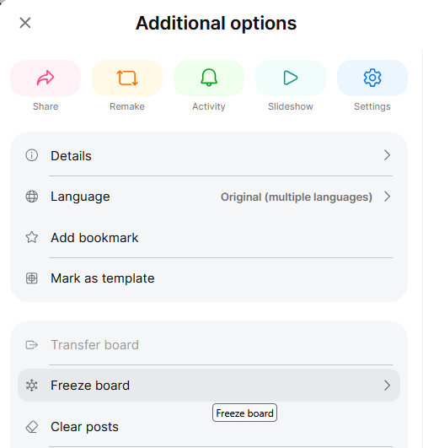
- Toggle on the "Freeze padlet?" option.
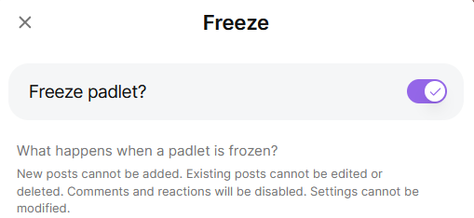

Update the Event Description / Communicating about No New Offers and Needs
That may include:
- Editing the Optional Preparation section to remove links to submit offers and needs and say something like "The deadline to submit offers and needs has passed." That's often better than someone clicking on a link and getting a generic 404 page because you froze your Padlet board.
- If you feel called to it, communicating with people – however and wherever you like – that the submission deadline has passed.

The Follow-Up
There are some over-the-top post-event steps that I personally take because my Captain Comprehensive nickname is well deserved. ;)
The only thing I truly recommend to you is sending a recap email. Consider everything else optional and probably excessive unless you plan to become a pro OANM facilitator.

(Optional) Export the Contents of Your Digital Wall
Here's how to do it in Padlet:
- Click the "Share" button on your board.
- Go to Export > Export CSV / Export Excel spreadsheet and click the link.
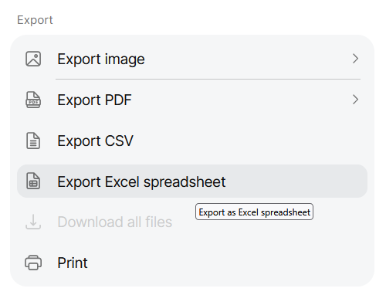
- Put the exported contents somewhere handy.

(Optional) Edit the Digital Wall Export
This is useful for at least two reasons:
- You may want to send the contents to the OANM participants … without their confusing typos, unexplained acronyms, offers tagged as needs (or visa versa), and more.
- You may want a personal copy to pull from for your future OANM purposes.
Consider editing only the parts that make sense to how you anticipate sharing or using the contents in the future.
- Delete any real-time examples you added in a demonstration phase of the market..
- Make sure the value in the Section and Offer or Need? columns match. In other words, people may add an offer to the needs side of the digital wall and this is your chance to reclassify it.
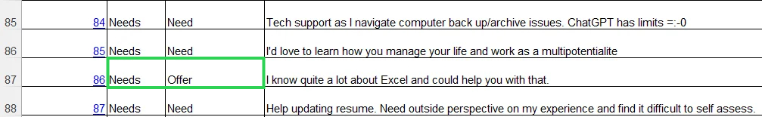
- Delete these columns
  - Section
  - Subject
  - Post color
  - Created At
  - Updated At
- Edit offers or needs descriptions that are too long, imprecise, confusing, use acronyms that you can't expect everyone to know, and whatever else is important to you. You might even split one offer or need into multiple ones if they're too long or not associated with each other.
- Remove extra spaces or correct poor formatting in the various spreadsheet columns.
- Remove default database values in optional or Padlet added columns (e.g., delete "No data" or "No comments" values).
- Using the filter drop-down on each column, look for values that are inconsistent (e.g., typos or weird formatting of a phone number) and change them. This is important because any participant may need to sort or filter on any spreadsheet column and data integrity is important.
- Change the width of any column that's too long and use text wrapping (e.g., on the Offer / Need Description).
- Run spell check on the spreadsheet.
- Shrink the columns to their tightest width so people don't have to scroll as much to the right to see more information.
- Sort the spreadsheet by Offer or Need column first (Z to A so the Offers are at the top), Author second, and Location third.
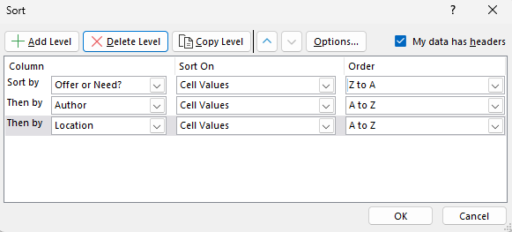
- If you're not already editing in a Google Sheet version of the spreadsheet, upload your version (e.g., Excel) to Google Drive.
- Change the Google Drive link access restrictions so anyone with the link (a.k.a. your participants) can view it.
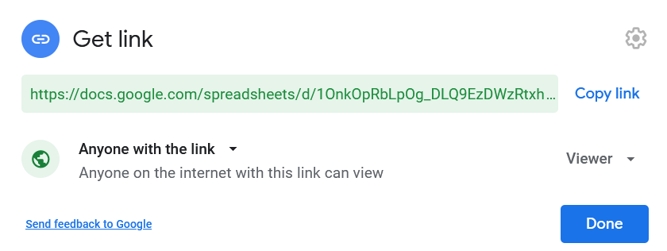
Note: I strongly recommend view only access so people don't mess with each other's offers and needs or unintentionally mess up your formatting. You can change the access to "Comment" instead if you want people to be able to interact about what they see without editing it.
- Distribute the edited spreadsheet however you see fit (email example).

(Optional) Aggregating Participants' Offers and Needs
If you're hard core like me, you want a single, aggregated place where the contents of all your OANMs live. Here's what to do if that sounds like a good idea to you.
- Click this Template: Offers and Needs Market Data Capturing Spreadsheet (Online) and download a copy.
- Rename the file.
Example: [YYYY-MM-DD] [Event Name] Online OANM Offers and Needs Capture Spreadsheet.xlsx
- (If necessary) Upload the Excel template copy to Google Drive if you'd rather use a Google Sheets version.
- Delete the placeholder rows 2-8 to show you what a populated template will start to look like.
- Delete any columns that are irrelevant to you (e.g., Potential Match).
- (If necessary) Consolidate columns. For example, you might want to make the "First Name" and "Last Name" columns just one column named "Author."
- Copy and paste the contents of the edited Digital Wall Export into the equivalent column in your Data Capturing Spreadsheet.
- (Optional) Add categories and subcategories. If you have more than 100 offers and/or needs in the OANM data capture spreadsheet, add a category for each offer and need. And if you have more than 300 rows, consider adding a subcategory for each offer and need. Sorting and filtering for the win!
Note: You might be able to use AI to categorize and sub-categorize as long as they don't store the data and don't share it. The last thing we want is for people's sensitive information to be used in unknown ways by AI companies.
Pro tip: Here are some suggested main categories for you to use: Accountability, Advice, Business, Coaching, Communication, Community, Connections, Content Creation, Creative, Design, Events, Food, Financial, Habits, Health, Information, Making, Marketing, Personal Finance, Physical, Productivity, Relationships, Research, Resources, Sharing, Skills, Teaching, Technology, Travel, Volunteering, Writing, Other, N/A (Not Applicable).
Pro tip: Here are some examples of subcategories for you to use. A more complete list might be hundreds of items long: Art, Editing, Entrepreneurship, Feedback, Fitness, Kids, Languages, Mindfulness, Music, Non-Profit, Nutrition, Parenting, Photography, Podcasting, Public Speaking, Referrals, Self-Publishing, Sleep, Social Media, Stories, Systems, Time Management, Video Production, Website, Other, N/A (Not Applicable).
Note: Go back through the Category and Subcategory columns and make sure the labels are consistent. For example, you might realize that "Health and Fitness" is too broad of a category and requires separating "Fitness" from "Health." Your "Health" label will also help you decide whether it’s too big, even for a master category, or whether it should be divided into "Physical Health," "Mental Health," and "Environmental Health" subcategory labels. Another example is consolidating "Connections," "Connection," and "Connecting" into simply "Connections".

The Recap Email
You want your participants to have a permanent place where they can find all the offers and needs. You'll also probably have specific and maybe time sensitive calls to action for them to do now that the event is over.
The recap email template below is intended to be sent 1-5 days after the real-time market ends. Sooner is better, but take the time you need to create or update any documents you link to in the email.

Email Template
Subject: [Community name] Offers and Needs Market recap + spreadsheet (the matches continue!)
Body:
Hey wonderful [humans/name the community or group refers to themselves as (e.g., multipotentialites)] who participated in our [date of event (e.g., "March 13")] Offers and Needs Market (OANM)!
I promised I'd give you the final offers and needs and they're right here [hyperlink the edited spreadsheet or wherever the permanent place is that offers and needs live on the anchor text "they're right here"]. As the connections and matches march on, I want to help you get even more from our experience.
First, I strongly encourage you to follow up on 1-3 offers or needs within the next week. It might be best to reach out about items you're most excited about, but action on anything is better than nothing.
OANMs are not just community-building exercises; they're also trust-building activities. So please remember to keep the contents of our OANM among people who actively participated (a.k.a. people you see in the linked resource above) [if relevant, mention others in the same group/community who didn't participate but can be trusted to keep the information private [(e.g., "or trusted fellow [name the community or group refers to themselves as (e.g., multipotentialites)"]].
Thanks again for letting me share one of my favorite gifts – the gift of a fantastic OANM!
[Your preferred sign-off (e.g., All the best, Joel Zaslofsky)]
P.S. Your survey feedback so far is super helpful! I have some key changes to make for the next OANM thanks to you. :)
And if you didn't complete the quick [X] minute survey like so many others, you can still do it here [hyperlink to the survey on the "do it here" anchor text].

Review the End of Event Survey Results
Some of the best changes you can make as a facilitator or in the way you run an OANM comes from direct feedback in your end of event survey. For example, I created this Digital Wall version of the process based on some tough, but fair feedback I got in the survey.
You also may have the seeds of some great testimonials or new relationships based on what people wrote. So go through the survey, mine the nuggets, express gratitude to people who gave you something useful, and take action on what people graciously offered up.

(Optional) The Other Stuff
Besides planning your next OANM, some "other stuff" might also be useful. For example, you might find it beneficial to follow-up with specific participants or participants in general to:
- Connect with them on LinkedIn or another social platform.
- Ask for a testimonial based on your interaction or their survey response.

Miscellaneous Tips

Facilitator Pro Tips
- If you want to use a different framework than the head/heart/hands/connection one to help people wrap their heads around what they might offer or request, OffersandNeeds.com has a good one.

What Now?
Did you enjoy your OANM experience and want to have one happen for another community you belong to? Contact your facilitator for details or send a note to Joel Zaslofsky so he can provide you with some resources.

Changelog
Version # | Date | Version Notes (e.g., what was added, modified, or deleted from the previous version)
1.0 | 2026-07-30 | Initial version

Other OANM Facilitator Guides
I've published other OANM facilitator guides over the years, and the ones below may be relevant to you.
Online / Offline | Style | Notes | Link
Offline | Default | N/A | Go here.
Online | Alternative | Requires participants do prep work and use forms / spreadsheets. It was my go-to process from 2017-2025. | Go here.

Acknowledgments
I probably would have never heard about the OANM if it were not for my friend, Donnie Maclurcan. He continues to be my go-to OANM resource and much of what you see in this facilitator guide is a variation of resources he's put together on running OANMs.
I couldn't do it without ya, Donnie! And neither could many of the people using this guide. Thank you!

Sharing, Modifying, or Copying This Guide
This guide is uncopyrighted, meaning you can copy, modify, and share it how you see fit – with or without attribution. Of course, hat tips are nice. :)

Photo Credits: Armosa Studios

